|  |  |  |  |  |
| --- | --- | --- | --- | --- |
| **Test Case** | **Execution History** |  |  |  |
| **Start Date** | **Start Time** | **End Time** | **Status** |
| **TC01-Verifying the functionality of Sign In** | **21/01/2019** | **17:57:31** | **17:57:31** | **Passed** |

|  |  |  |  |
| --- | --- | --- | --- |
| **Step Description** | **Expected Result** | **Actual Result** | **Status** |
| Step: Open the woolworths mobi one application | Application should be open | As Expected | **Passed** |

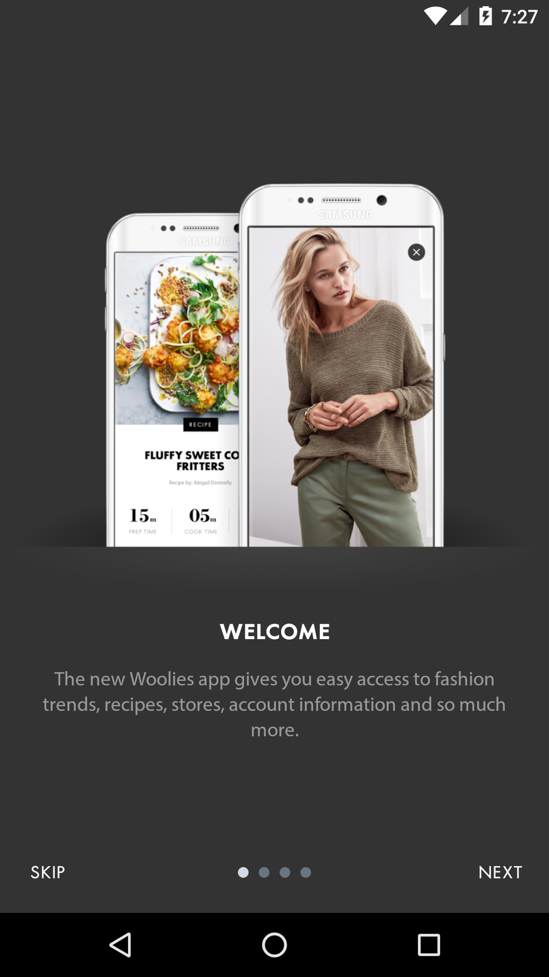

|  |  |  |  |
| --- | --- | --- | --- |
| **Step Description** | **Expected Result** | **Actual Result** | **Status** |
| Step: Click on skip to close the skip page | Skip page should be close | As Expected | **Passed** |

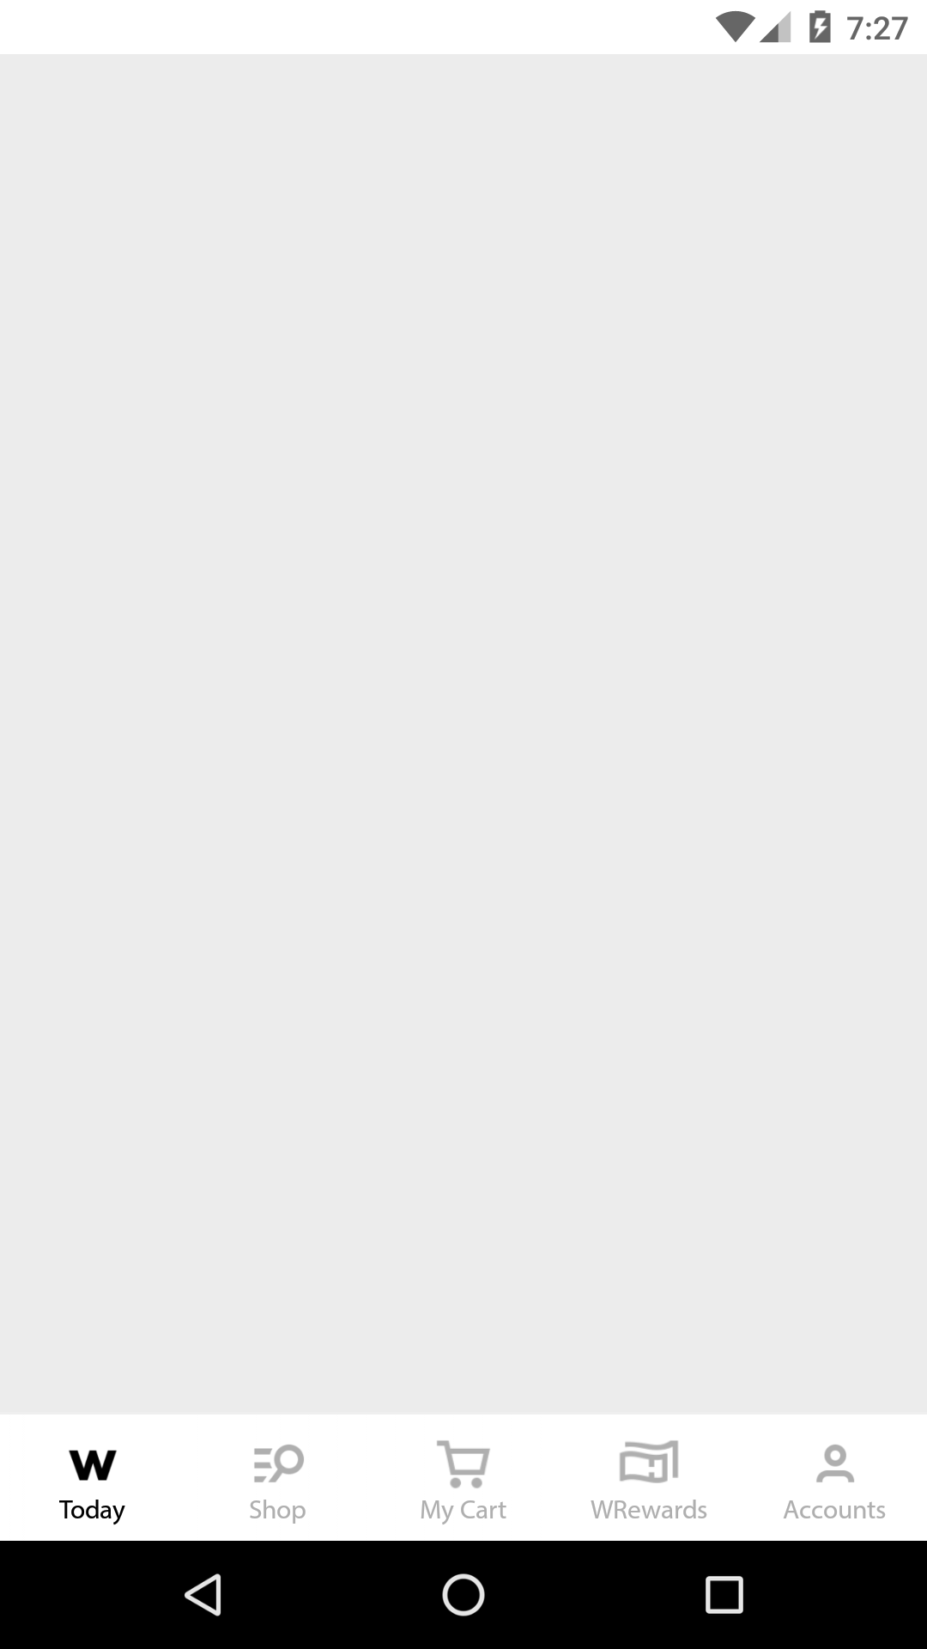

|  |  |  |  |
| --- | --- | --- | --- |
| **Step Description** | **Expected Result** | **Actual Result** | **Status** |
| Step: Click on Account | Account page should display | As Expected | **Passed** |

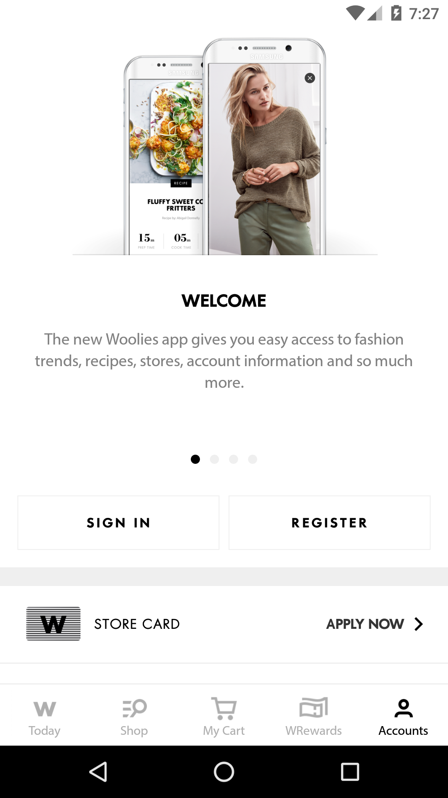

|  |  |  |  |
| --- | --- | --- | --- |
| **Step Description** | **Expected Result** | **Actual Result** | **Status** |
| Step: Click on Sign In | Sign In page should display | As Expected | **Passed** |

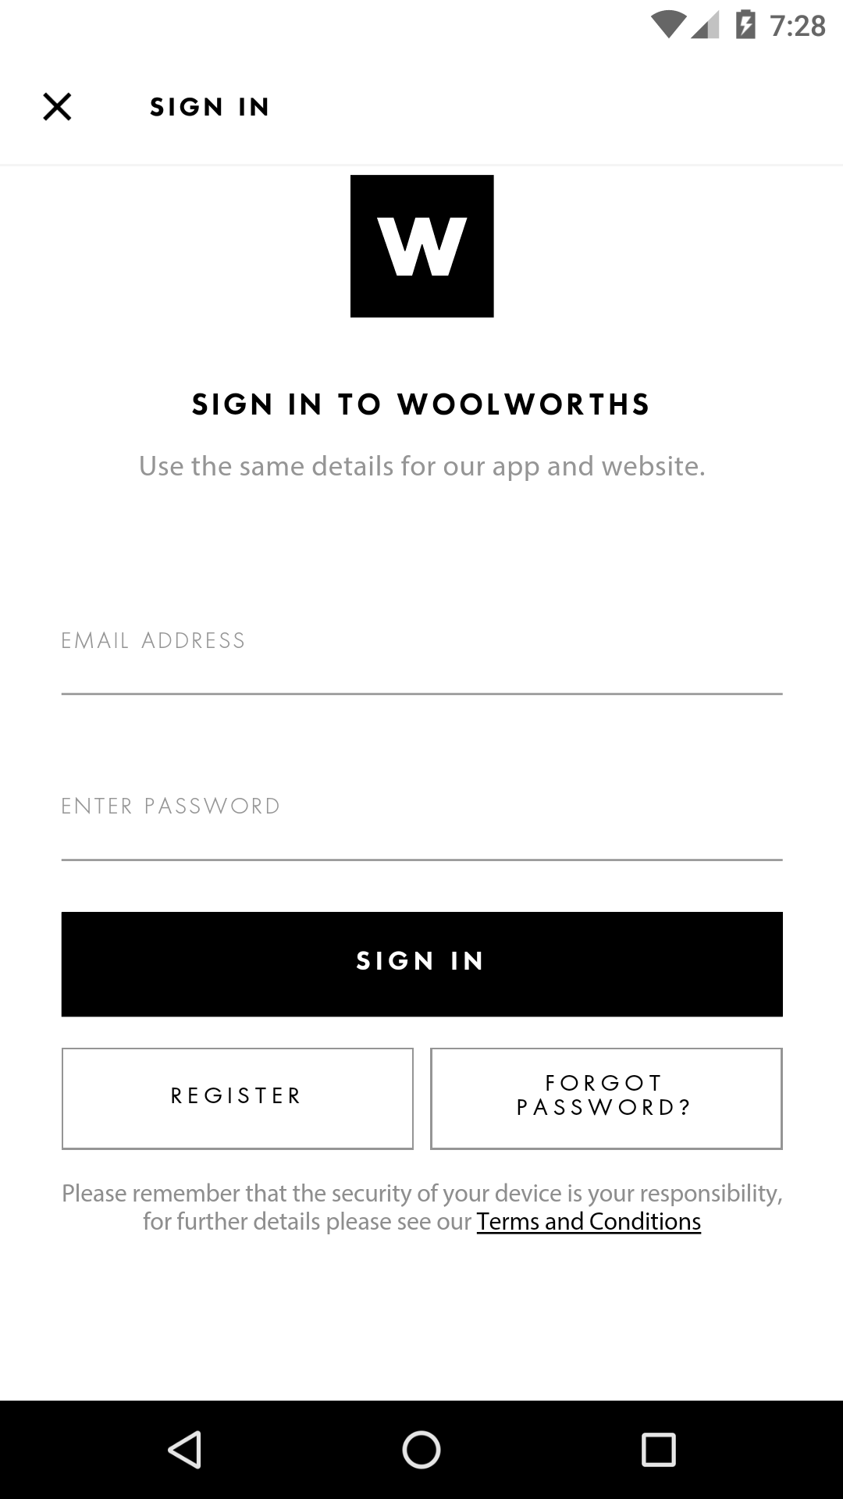

|  |  |  |  |
| --- | --- | --- | --- |
| **Step Description** | **Expected Result** | **Actual Result** | **Status** |
| Step: Enter the valid userName and valid password in the respective fields | Username and passowrd field should accept the values | As Expected | **Passed** |

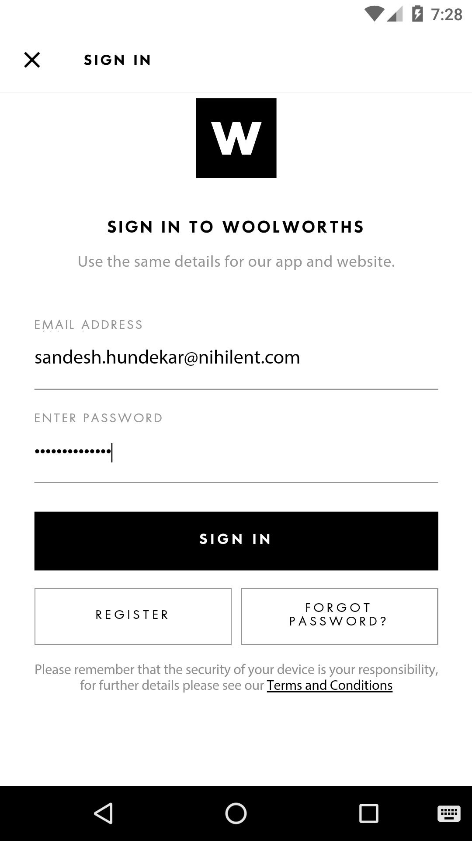

|  |  |  |  |
| --- | --- | --- | --- |
| **Step Description** | **Expected Result** | **Actual Result** | **Status** |
| Step: Click on Sign In button to login into account | User should be loged in successfully and user account home page should be display | As Expected | **Passed** |

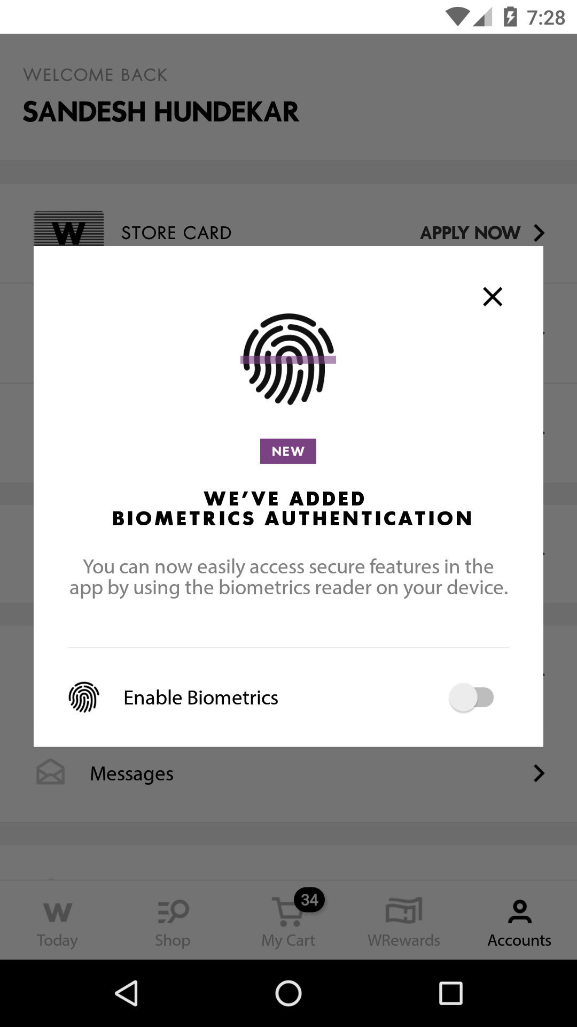

|  |  |  |  |
| --- | --- | --- | --- |
| **Step Description** | **Expected Result** | **Actual Result** | **Status** |
| Step: Click on Account | Account page should display | As Expected | **Passed** |

